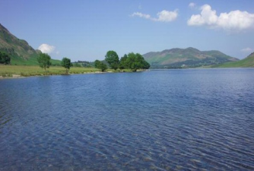

Approach

Note

(ISO: 9001 certified unit)

**Modernisation of SMS**

**Bokaro Steel Plant**

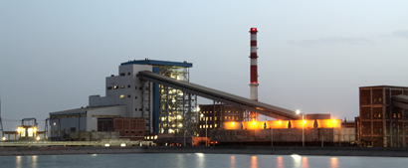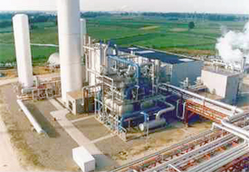

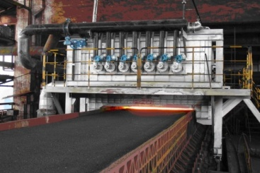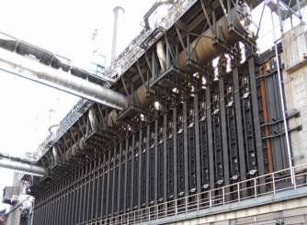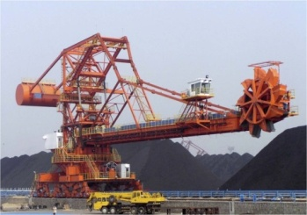

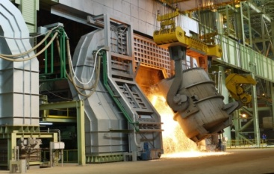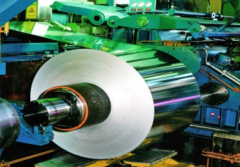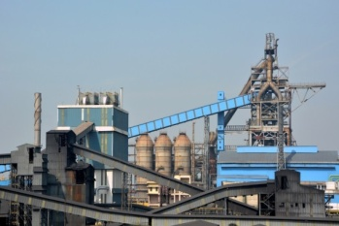

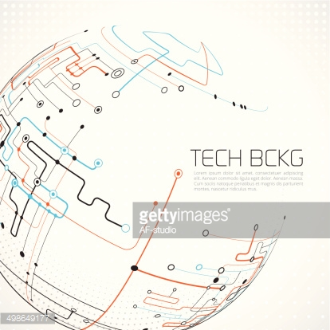





**Centre for Engineering & Technology**

**AUGUST 2016 RN/4900/An/st/01/R=0**

**This document has been prepared for <XYZ> by:**

Centre for Engineering & Technology

<Name of HOD> – HOD Lead section

<Name of Task Force Leader> (Task Force Leader)

<Name of TFM 1>, <Discipline >

<Name of TFM 2>, <Discipline >

<And so on.>

|  |  |
| --- | --- |
| Document Identification No. | ***<Document No.>*** |

**REVISION HISTORY**

|  |  |  |
| --- | --- | --- |
| **Revision No.** | **Brief Description** | **Revision Date** |
| R3 |  |  |
| R2 |  |  |
| R1 |  |  |

*Disclaimer*

*This document is the property of CET and is exclusively for the use of the intended client. This document has been prepared based on the inputs provided by the client. No part of this report shall be reproduced or transmitted in any form whatsoever without the written permission from the owner.*

**CONTENTS - CHAPTERS**

|  |  |  |
| --- | --- | --- |
| **Chapter no.** | **Description** | **Page no.** |
| 1 | Background |  |
| 2 | Analysis |  |
| 3 | Approach |  |
| 4 | Conclusion |  |

1. **BACKGROUND**

* There will be no Summary in AN.
* AN will start from Background
* Contents of the chapter will be as followed for similar chapter for FR.

1. **ANALYSIS**

This chapter will mainly include analysis, evaluation and various aspects of existing system or technology as per requirement of the project.

1. **APPROACH**

* This chapter will list out various approaches comprising of number of alternatives as the case may be to achieve the given target or specific parameters.
* The alternatives suggested along with their merits de merits ***(If mentioned)*** may be divided in short and long term on case to case basis.
* Alternatives suggested should be accompanied with block cost of individual proposal wherever possible.

1. **CONCLUSION**

* In this chapter various proposal considered can be summarized in tabular form :

|  |  |  |  |
| --- | --- | --- | --- |
| **S. No.** | **Description** | **Duration** | **Block Cost** |
| 1 | Proposal A | Short Term |  |
| 2 | Proposal B | Long Term |  |
| 3 | Proposal C | Long Term |  |

* This chapter can also include any remarks which help the top management to take decisions for further course of action.

**Instructions to follow while preparing Reports:**

# Cover page

## Text font and size to be retained

## Photographs are standard and same to be retained

## Make necessary changes within areas marked “<text>”

# Remaining pages

## Font and size to be used for heading: Segoe UI size 14

## Colour of heading is BLUE and to be retained

## Font and size for the body of the report: Segoe UI size 12

## Colour of body of the report is BLACK

# Tables

## Colour, shades for rows, font shall be as per the example below.

|  |  |  |
| --- | --- | --- |
| **<Heading 1>** | **<Heading 2>** | **<Heading 3>** |
| <body> | <body> | <body> |
| <body> | <body> | <body> |
| <body> | <body> | <body> |
| <body> | <body> | <body> |

## Number of rows and columns may be added / deleted as per requirement

# Location

## Maps of all SAIL steel plant locations shall be available at CET portal for use.

## For instance: Location of Bhilai Steel Plant

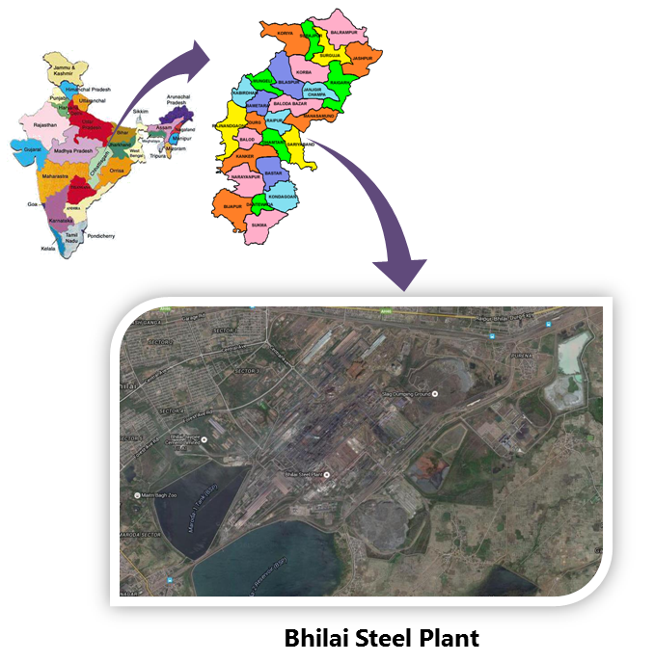

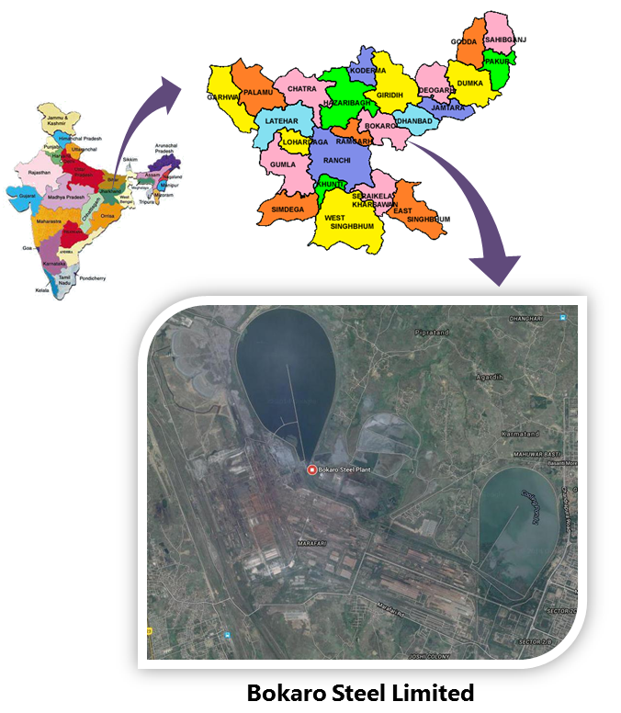

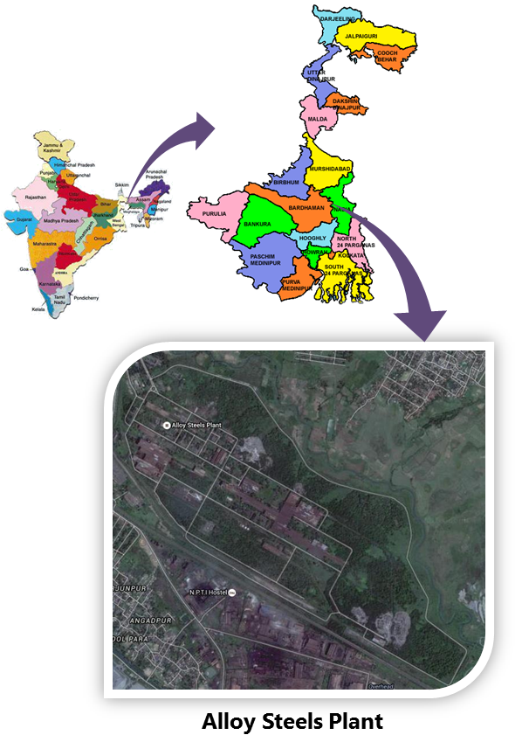

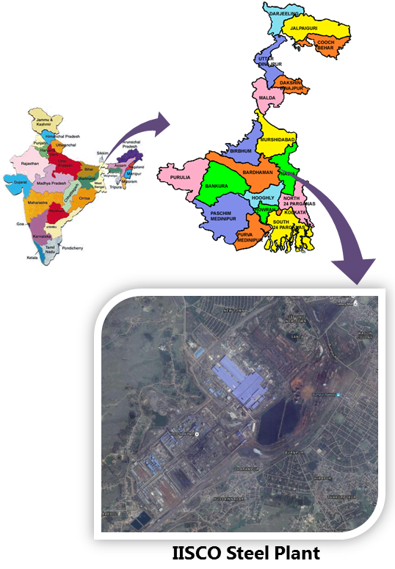

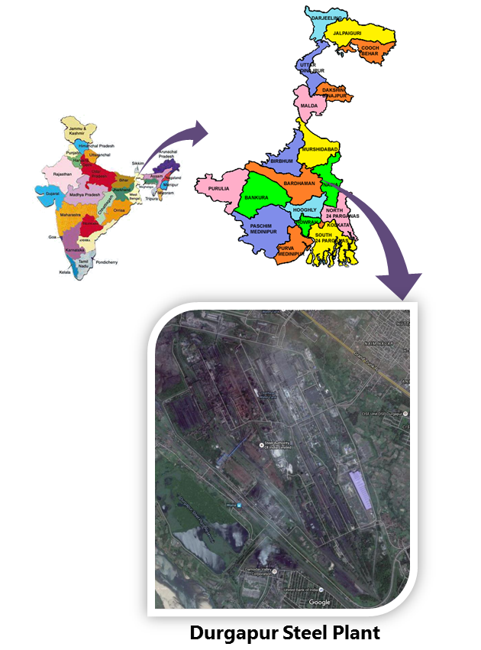

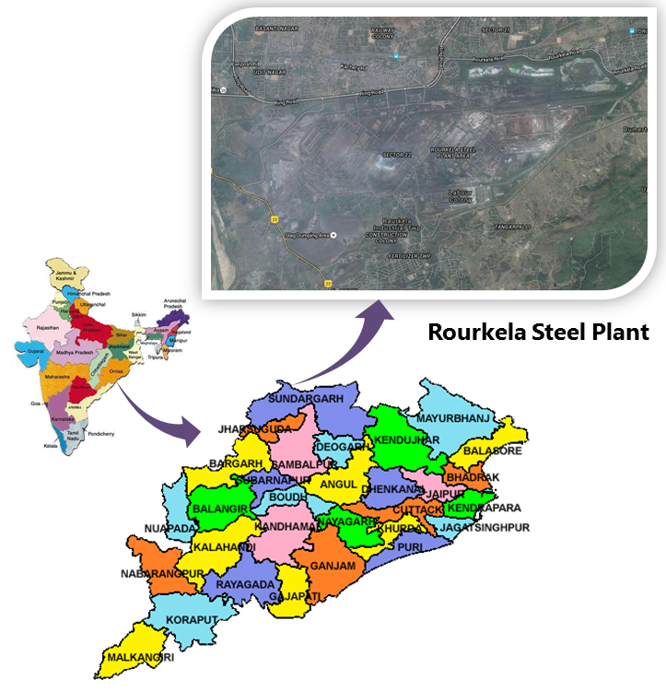

# General instructions to be observed:

## Pie-charts, bar charts or any suitable graphical representation shall be used to depict data wherever possible.

## Example:

## Costing may be represented as

## Components of data may be represented as (example shows various components of coal blend)

## Smart art in Microsoft word tab can be used. Word> Insert>Smart Art

## Charts in Microsoft word tab can be used. Word> Insert>Chart

## Example

## The line graph